Project Name | McElhanney Project Number | Client Project Number
Project Name | 2451-XXXX-XXX | XXXXX
Contractor | Client Name
Full Contractor Name | Client Name
Report Date | Prepared On
June 3, 2025 | June 3, 2025
Arrival Time on Site | Departure Time from Site
8:00am | 5:00pm
Weather (AM) | Weather (PM)
10°C, Sunny | 20°C, Cloudy
Prepared By
Report Writer, Credentials

- VISITORS

Name | Role | Company | Note | Time in/out
N/A

- CONSTRUCTION PROGRESS

Location | Activities
Sta 0+280 to 0+315 | Roadway Gravels – Excavation of existing roadway gravels continued today for re-use at Glenwood Ave:  - Road gravels were excavated along the full road width of Morrison Ave.
Sta 0+007 to 0+040 | Conduit Install – Installation of the PVC storm conduit was started today:  - Installation of the new solid 300 mm PVC storm stub from Richter St to existing drywell DW1 was completed. Refer to Item #1 in Section 3 of this report for details.  - Installation of the new perforated 300 mm PVC storm upstream of existing drywell DW1 was started.

- ENGINEERING AND RECOMMENDATIONS

Item # | Note
1 | During the installation of the new solid 300 mm PVC storm stub from Richter St to existing drywell DW1, CGL confirmed that there was a direct conflict between the existing shallow utility duct bank along the east side of Richter St and the new storm main:  - McElhanney noted that the new 300 mm PVC storm main should be installed under the existing duct bank to ensure minimum cover is achieved, with a maximum slope of ~2% to prevent the future extension of the PVC main into Richter St from ending up too deep.  - CGL noted that they installed the new storm stub with an invert of 343.71 m at DW1, and an invert of 343.62 m at the end of the stub in Richter St (resulting in a slope of ~1.3%).  - CGL’s surveyor collected as-built data for the installed storm stub.  - Refer to the first photo in Section 8 of this report.

- CONVERSATIONS AND GENERAL NOTES

Item # | Note
1 | During the installation of the new solid 300 mm PVC storm stub from Richter St to existing drywell DW1, CGL confirmed that there was a direct conflict between the existing shallow utility duct bank along the east side of Richter St and the new storm main. McElhanney and CGL coordinated an adjustment to the storm pipe slope and elevation, as described in Item #1, Section 3 of this report.

- WORKFORCE

Estimated Quantity | Role | Name | Company | Note | Estimated Time Onsite
1 | Superintendent | Rob Reitman | CGL |  | 4 hrs per day
5 | General Laborer |  | CGL |  | 10 hrs
2 | Operator |  | CGL | Excludes haul truck drivers. | 10 hrs
/ | Surveyor/ Laborer |  | CGL
2 | Traffic Control Personnel | Payton & Nicole | CGL |  | 10 hrs

- EQUIPMENT

Equipment | Location | Activity | Estimated Usage  (per unit)
JD 345G Excavator | Sta 0+007 to 0+040 | Installation of storm conduit. | 10 hrs
JD 300 Excavator | Sta 0+280 to 0+315 | Excavation of existing roadway gravels. | 10 hrs
Haul Truck (rotating) | Sta 0+007 to 0+315 | Transport of excavated road gravels to Glenwood Ave & removal of trench material. | 10 hrs

- OBSERVATIONS

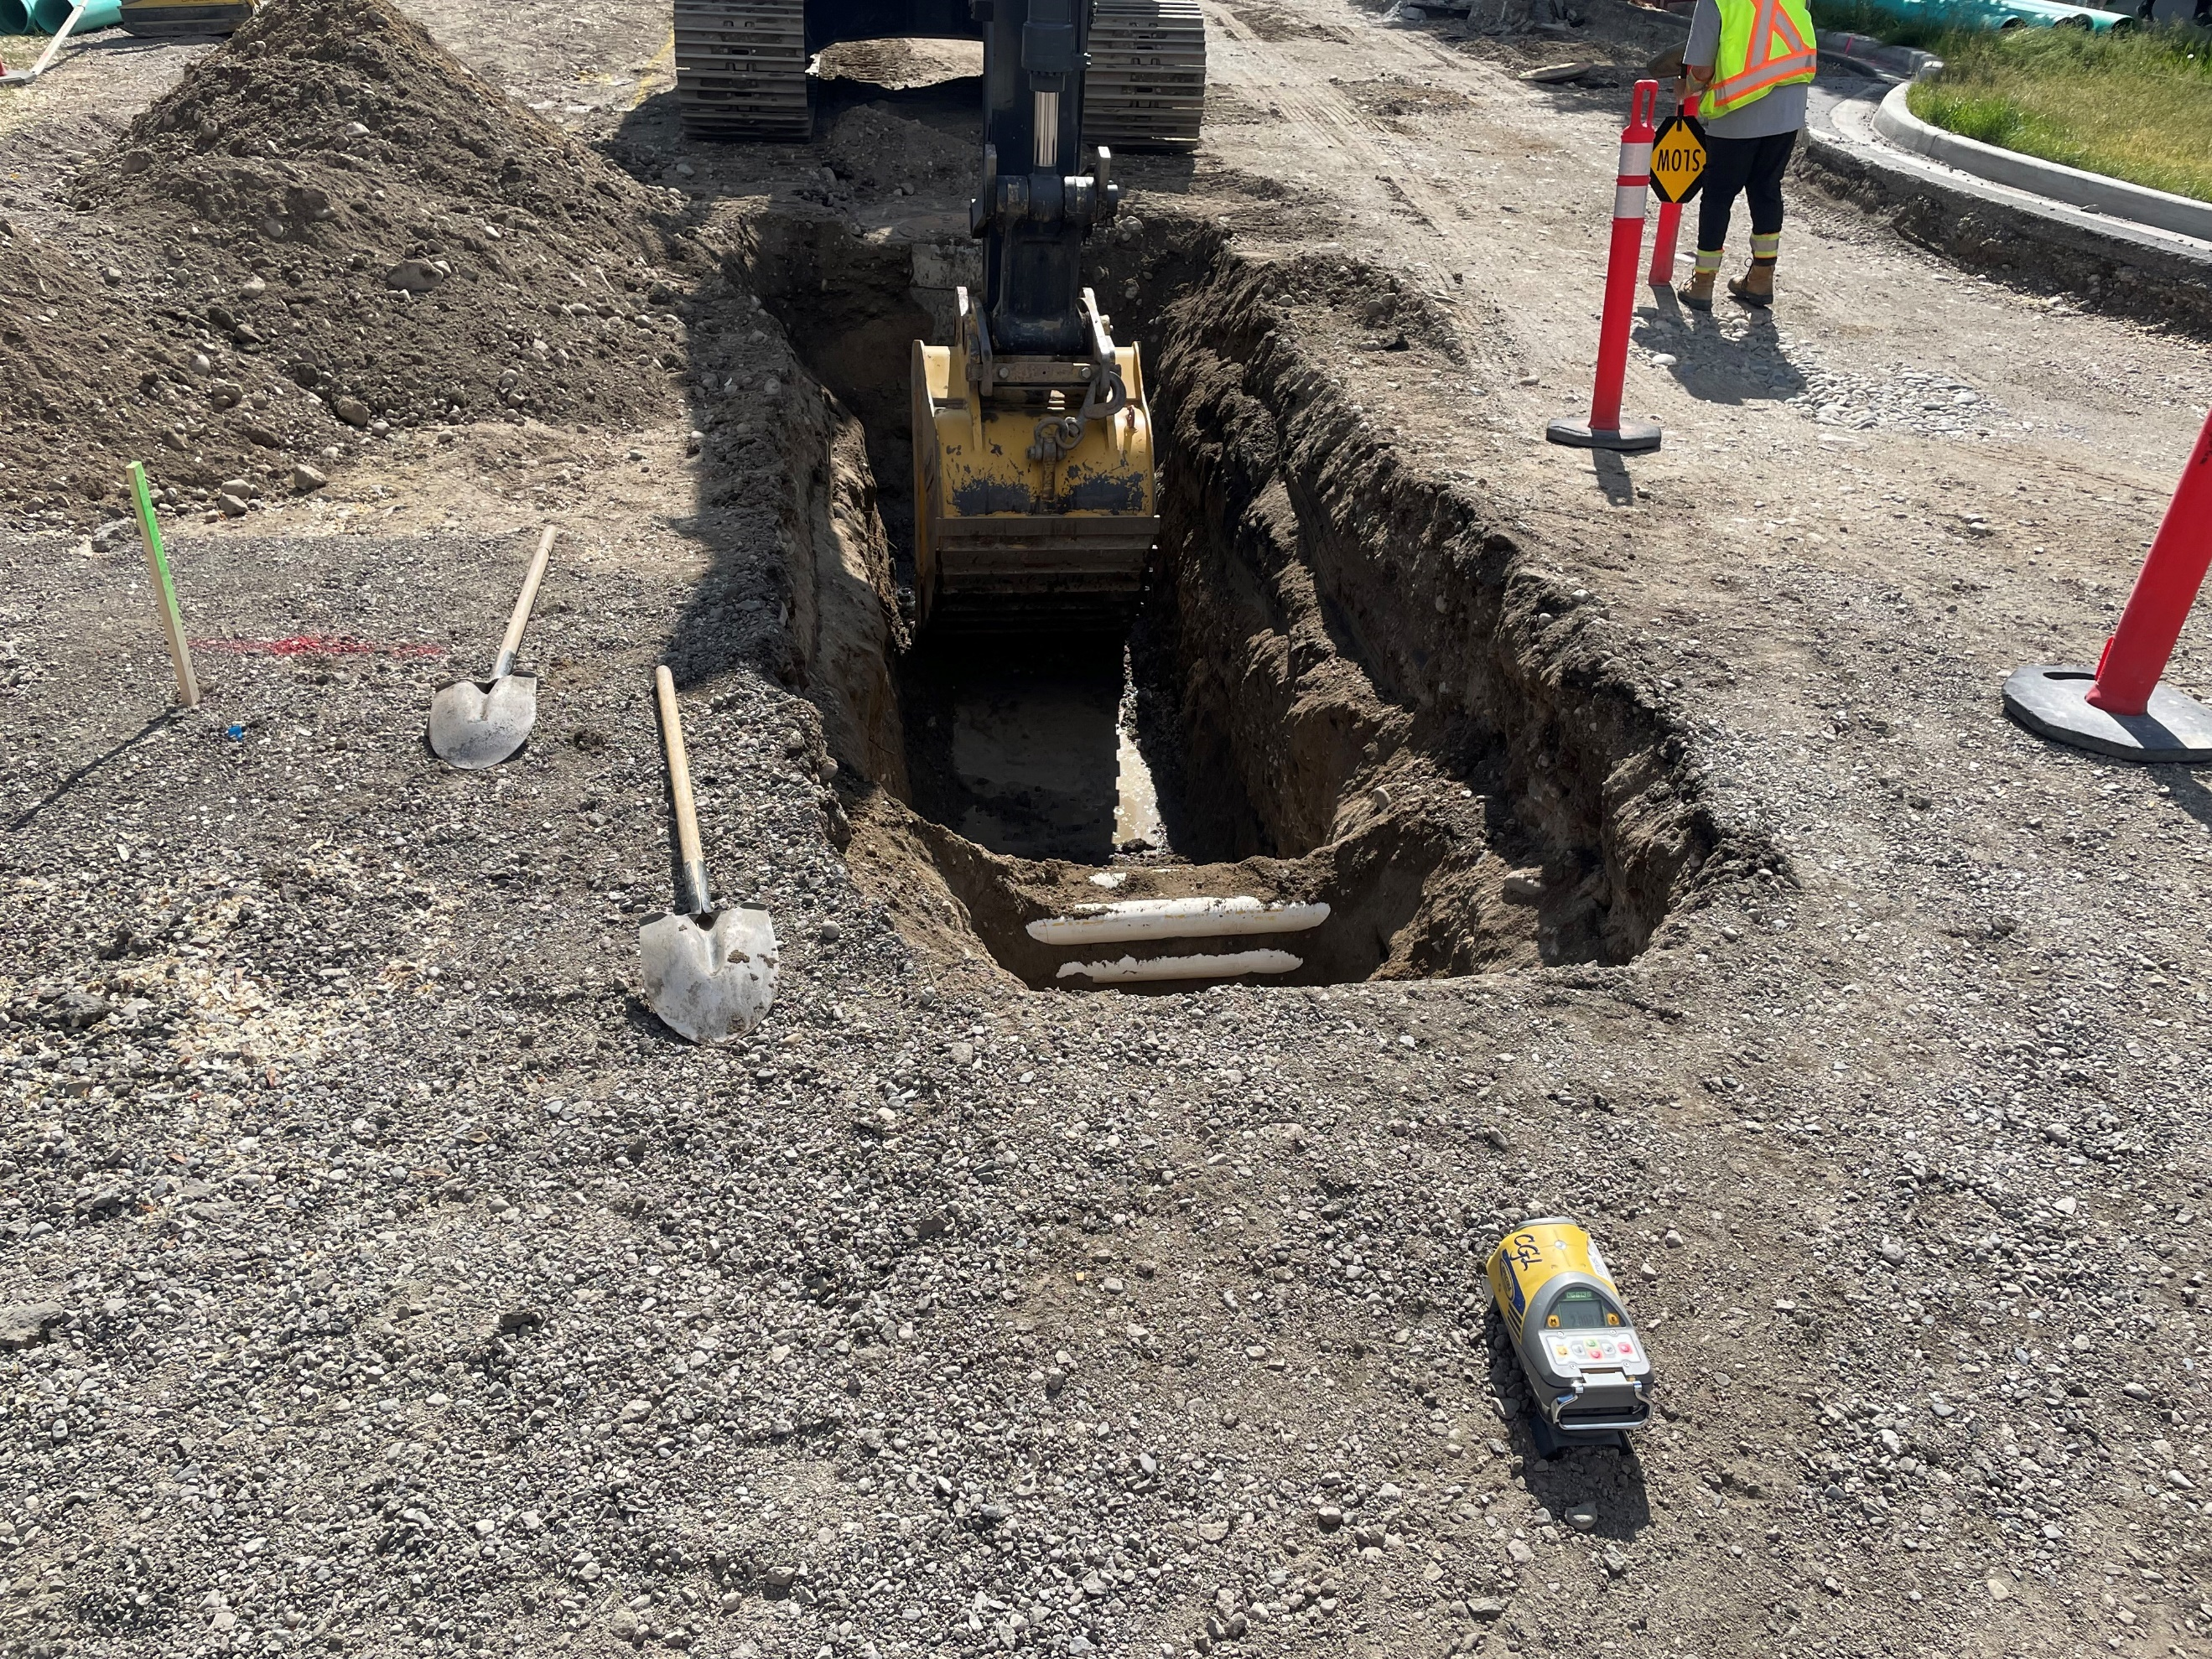
Photo 1
Excavation of the ground to find some utilities, and there’s shovels on the ground and a pipe laser.
Location  STA 0+123, looking Southeast | Timestamp  Thursday January 1, 2025, 7:45am

Photo 2
Excavation of the ground to find some utilities, and there’s shovels on the ground and a pipe laser.
Location  STA 0+123, looking Southeast | Timestamp  Thursday January 1, 2025, 7:45am

Photo 3
Excavation of the ground to find some utilities, and there’s shovels on the ground and a pipe laser.
Location  STA 0+123, looking Southeast | Timestamp  Thursday January 1, 2025, 7:45am

Photo 4
Excavation of the ground to find some utilities, and there’s shovels on the ground and a pipe laser.
Location  STA 0+123, looking Southeast | Timestamp  Thursday January 1, 2025, 7:45am

Photo 5
Excavation of the ground to find some utilities, and there’s shovels on the ground and a pipe laser.
Location  STA 0+123, looking Southeast | Timestamp  Thursday January 1, 2025, 7:45am

Photo 6
Excavation of the ground to find some utilities, and there’s shovels on the ground and a pipe laser.
Location  STA 0+123, looking Southeast | Timestamp  Thursday January 1, 2025, 7:45am

Photo 7
Excavation of the ground to find some utilities, and there’s shovels on the ground and a pipe laser.
Location  STA 0+123, looking Southeast | Timestamp  Thursday January 1, 2025, 7:45am

Photo 8
Excavation of the ground to find some utilities, and there’s shovels on the ground and a pipe laser.
Location  STA 0+123, looking Southeast | Timestamp  Thursday January 1, 2025, 7:45am

Prepared By | Reviewed By
Name, Credentials | Name, Credentials

